CHAROTAR UNIVERSITY OF SCIENCE AND TECHNOLOGY
FACULTY OF TECHNOLOGY AND ENGINEERING
CHANDUBHAI S. PATEL INSTITUTE OF TECHNOLOGY
OCCE4001 - SOFTWARE TESTING

PRACTICAL LIST – AY: 2026- 27
Sr. no. | Title | CO/PO
3. | Title : Cross Browser Testing using Selenium  Aim : To verify application compatibility across browsers.  Software Required  - Selenium  - Chrome  - Firefox  - Edge  Procedure  - Configure browser drivers.  - Execute same script.  - Compare results.  - Identify browser issues.  Expected Outcome: Cross-browser compatibility verified.  Result: Application tested on multiple browsers. | CO4 / PO1, PO2, PO3, PO5 and PO12
Solution:
1) Check python in system , “python --version” , “python3 --version”
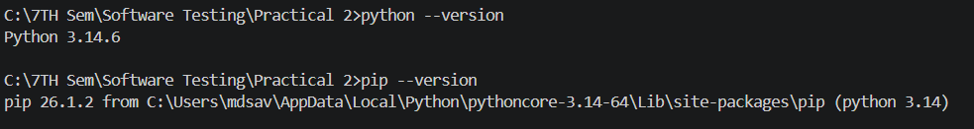
2) run command “pip3 install selenium”
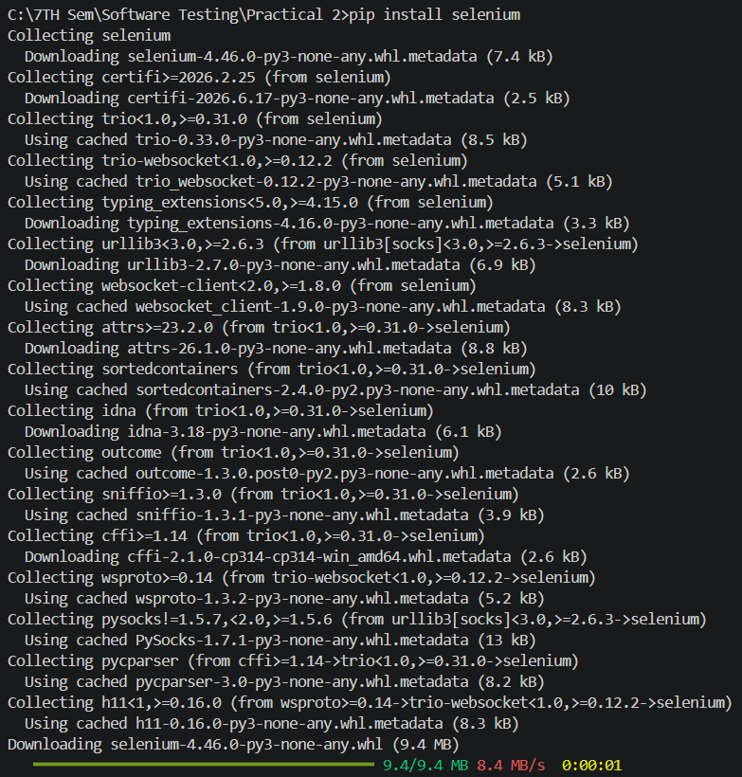
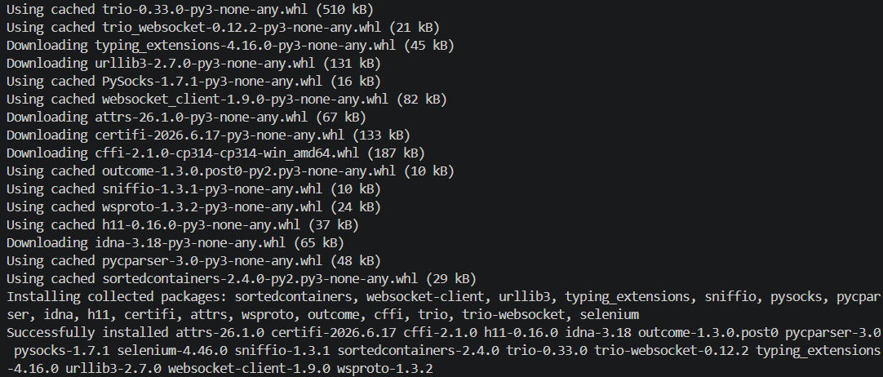

3)Open IDE and make “prac3.py” and write Script.

from selenium import webdriver
from selenium.webdriver.common.by import By
import time

def run_test(browser_name):
print(f"\n--- Running test on {browser_name} ---")

if browser_name == "Chrome":
driver = webdriver.Chrome()
elif browser_name == "Firefox":
driver = webdriver.Firefox()
elif browser_name == "Edge":
driver = webdriver.Edge()

driver.implicitly_wait(10)
driver.maximize_window()

start_time = time.time()
driver.get("https://www.saucedemo.com")

driver.find_element(By.ID, "user-name").send_keys("standard_user")
driver.find_element(By.ID, "password").send_keys("secret_sauce")
driver.find_element(By.ID, "login-button").click()

time.sleep(2)

title = driver.title
print(f"{browser_name} - Page Title:", title)

try:
logo = driver.find_element(By.CLASS_NAME, "app_logo")
if logo.is_displayed():
print(f"{browser_name} - Test Passed - Assertion Successful")
except:
print(f"{browser_name} - Test Failed")

end_time = time.time()
print(f"{browser_name} - Time Taken: {round(end_time - start_time, 2)} seconds")

# Extra wait for screenshot - window will stay on screen
print(f"{browser_name} - Window open for screenshot, waiting 4 seconds...")
time.sleep(4)

driver.quit()

# Run test on all browsers
run_test("Chrome")
run_test("Firefox")
run_test("Edge")

print("\nAll browser tests completed!")

Output :
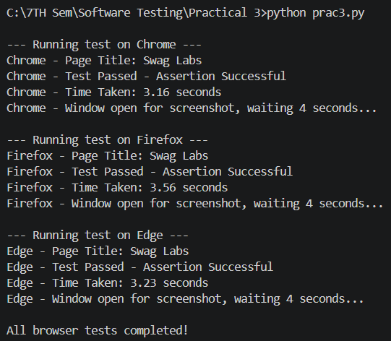
Reference Youtube Video:
https://www.youtube.com/watch?v=YEhnSrdLcHE

